**Hadoop Exercise-7 Q2**

**Question 2 ) Implement a simple map-reduce code for the wordcount problem using Python and then run the code using HDFS**

1. Start all Deamons

1. Directory Structure in Local Filesystem

/home/hadoop/hadoop/

├── wordcount_python/

├── input.txt

├── mapper.py

├── reducer.py

├── random_input.txt

1. Directory Structure in HDFS (or) Browser Directory

/hadoop/ (user)

├── hadoop/ (parent folder)

├── wordcount_python/

├── input/

├── input.txt

├── output/

├── _SUCCESS

├── part-00000

1. Set up Directory Structure



1. Create custom input to check the mapper and reducer programs

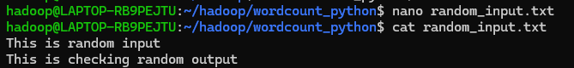

1. Create a Mapper in Python

NOTE: DO NOT REMOVE THE #! LINE. ‘ #!’ IS CALLED A SHEBAND AND INDICATES THE SCRIPT IS BEING INTERPRETED IN A PYTHON ENVIRONMENT INSTEAD OF A SHELL ENVIRONMENT.

1. Create a Reducer in Python

NOTE: DO NOT REMOVE THE #! LINE. ‘ #!’ IS CALLED A SHEBAND AND INDICATES THE SCRIPT IS BEING INTERPRETED IN A PYTHON ENVIRONMENT INSTEAD OF A SHELL ENVIRONMENT.

1. Check if they run locally using streaming

1. Create the actual Input file

1. Create the directory structure in Hadoop for input



1. Change the permissions for the mapper and reducer file else it will give error while doing Hadoop streaming



1. Use Hadoop Streaming to run the job

-input : location of input in HDFS

-output : where you want the output to be stored in HDFS

-mapper : path of mapper in local filesystem (the dot before the first slash indicates cwd)

-reducer : path of reducer in local filesystem (the dot before the first slash indicates cwd)

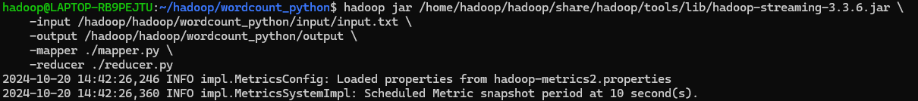

1. View the results

1. Stop all daemons

